F  R  A  M  E  #1 | 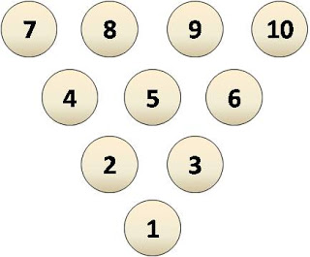 | My Work | 1st Roll 2nd Roll  Total
Bowl-a-Fact Recording Sheet
Van de Walle, J. et al. (2012). Elementary and Middle School Mathematics: Teaching Developmentally: The Professional Development Edition. Pearson. p. 186.

F  R  A  M  E  #2 |  | My Work | 1st Roll 2nd Roll  Total

F  R  A  M  E  #3 |  | My Work | 1st Roll 2nd Roll  Total

F  R  A  M  E  #4 |  | My Work | 1st Roll 2nd Roll  Total

F  R  A  M  E  #5 |  | My Work | 1st Roll 2nd Roll  Total

F  R  A  M  E  #6 |  | My Work | 1st Roll 2nd Roll  Total

F  R  A  M  E  #7 |  | My Work | 1st Roll 2nd Roll  Total

F  R  A  M  E  #8 |  | My Work | 1st Roll 2nd Roll  Total

F  R  A  M  E  #9 |  | My Work | 1st Roll 2nd Roll  Total

F  R  A  M  E  #10 |  | My Work | 1st Roll 2nd Roll 3rd Roll 4th Roll  Total

Bowl-a-Fact

Directions:
Take three dice and roll them. Students use the numbers on the three dice to come up with equations that result in answers that are on the pins. For example, if you roll 4, 2, and 3, they can “knock down” the 5 pin with 4 x 2 – 3. If they can produce equations to knock down all 10 pins, they get a strike. If not, roll again and see whether they can knock the rest down for a spare. After doing this with the whole class, students can work in groups.

Notes:
1) If students are unfamiliar with bowling, you may need to show a short video clip.
2) You may need to teach them how to score in bowling.
3) If your PE teacher is teaching a unit that involves bowling, that would be a good time to use this game and reinforce the content.

Van de Walle, J. et al. (2012). Elementary and Middle School Mathematics: Teaching Developmentally: The Professional Development Edition. Pearson. p. 186.

