**District Professional Growth and Effectiveness Plan**

**PROFESSIONAL GROWTH AND EFFECTIVENESS SYSTEM OVERVIEW**

Effective teaching and school leadership depend on clear standards and expectations, reliable feedback, and the tools, resources and support for pro­fessional growth and continuous improvement. The Kentucky Department of Education, with the guidance and oversight of various steering committees, has designed, developed, field tested and piloted a new statewide Professional Growth and Effectiveness System (PGES).

With the passage of Senate Bill 1 in 2009, Kentucky embarked on a comprehensive system of education reform integrating:

* + - relevant and rigorous standards
    - aligned and meaningful assessments
    - highly effective teaching and school leadership
    - data to inform instruction and policy decisions
    - innovation
    - school improvement

All are critical elements of student success, but it is effective teaching supported by effective leadership that will ensure all Kentucky students are successful and graduate from high school college/career-ready.

The PGES is designed to measure teacher and leader effectiveness and serve as a catalyst for professional growth and continuous improvement, and is a key requirement of Kentucky’s Elementary and Secondary Education Act (ESEA) flexibility waiver and the state’s Race to the Top grant.

**District Guide for Using This Document**

This document serves as a model plan for a district evaluation team (50/50 committee) to revise their existing Certified Evaluation Plans (CEP) to meet the assurances of the Professional Growth and Effectiveness System. All revised CEPs must be submitted to the Kentucky Department of Education (KDE) no later than **December 2014**.

This document has been designed to clearly note areas of required components and district flexibility. Required components are in a bulleted list. Local decisions are bulleted with arrows and boxes indicate provided options. **Local District Decision** sections are highlighted in *[GRAY]* and should be completed by the district. Include any supporting documentation that may serve to further explain district processes or procedures.

* = Required
* = Local Decision
* = Options provided

Once all sections are completed, the district must submit the plan to the local board for approval and adoption prior to submission to the KDE.

While it is not required that districts adopt this form when revising their CEPs, all CEPs must meet the assurances found within this document.

**Guiding Questions for Local Boards of Education**

The following questions may be useful to local boards as they consider approval and adoption of their districts’ revised CEPs.

* Set clear and high expectations
  + - What are our expectations across the district for our new effectiveness system (i.e., roles of superintendents, administrators, teachers)?
    - How will we ensure expectations are high and are communicated clearly to every educator in our district?
* Create the conditions for success
  + - What resources are needed to support successful implementation of the Professional Growth and Effectiveness System?
    - What can the board do to support teachers and leaders as they build capacity within the district?
    - What data will we review at our board meetings and how often?
    - What can the board do to support the work of our superintendent, principals, and SBDM councils to ensure that every school has highly effective teachers and leaders?
* Create the public will to succeed
  + - What is our responsibility to positively communicate the new effectiveness system and its impact to the public?
    - How often will district progress and data be made available to the community?
* Learn as a board team
  + - How will we be adequately informed about the new effectiveness system so that we can hold the system accountable and provide the appropriate supports and resources?
    - How will we keep current of revisions and progress of the new system?

**Professional Growth and Effectiveness System – Certified Teacher**

The vision for the Professional Growth and Effectiveness System (PGES) is to have every student taught by an effective teacher.  The goal is to create a fair and equitable system to measure teacher effectiveness and act as a catalyst for professional growth.

**Roles and Definitions**

1. **Administrator:** means an administrator who devotes the majority of employed time in the role of principal, for which administrative certification is required by the Education Professional Standards Board pursuant to 16 KAR 3:050
2. **Evaluator:** the immediate supervisor of certified personnel, who has satisfactorily completed all required evaluation training and, if evaluating teachers, observation certification training.
3. **Evaluatee:** District/School personnel that is being evaluated
4. **Peer Observer:** Observation and documentation by a trained colleague, selected as described in the district’s Professional Growth and Effectiveness System plan, who observes and documents another teacher’s professional practice and provides supportive and constructive feedback that can be used to improve professional practice**.**
5. **Professional Growth Plan:** An individualized plan that is focused on improving professional practice and leadership skills and is aligned with educator performance standards and student performance standards, is built using a variety of sources and types of student data that reflect student needs and strengths, educator data, and school/district data, is produced in consultation with the evaluator
6. **Self-Reflection:** means the process by which certified personnel assess the effectiveness and adequacy of their knowledge and performance for the purpose of identifying areas for professional learning and growth
7. **Student Voice:** the state-approved student perception survey, administered each year, that provides data on specific aspects of the classroom experience and of teaching practice.
8. **Other:** *[Please provide any additional required definitions for this section.]*

**The Kentucky Framework for Teaching**

The Framework for Teaching is designed to support student achievement and professional practice through the domains of Planning and Preparation, Classroom Environment, Instruction, and Professional Responsibilities. The Framework also includes themes such as equity, cultural competence, high expectations, developmental appropriateness, accommodating individual needs, effective technology integration, and student assumption of responsibility. It provides structure for feedback for continuous improvement through individual goals that target student and professional growth, thus supporting overall school improvement. Evidence supporting a teacher’s professional practice will be situated within one or more of the four domains of the framework. Performance will be rated for each component according to four performance levels: Ineffective, Developing, Accomplished, and Exemplary. The summative rating will be a holistic representation of performance, combining data from multiple sources of evidence across each domain.

The use of professional judgment based on multiple sources of evidence promotes a more holistic and comprehensive analysis of practice, rather than over-reliance on one individual data point or rote calculation of practice based on predetermined formulas. Evaluators will also take into account how educators respond to or apply additional supports and resources designed to promote student learning, as well as their own professional growth and development. Finally, professional judgment gives evaluators the flexibility to account for a wide variety of factors related to individual educator performance, such as: school-specific priorities that may drive practice in one domain, an educator’s number of goals, experience level and/or leadership opportunities, and contextual variables that may impact the learning environment, such as unanticipated outside events or traumas.

Evaluators must use the following categories of evidence in determining overall ratings:

**Required Sources of Evidence**

* + Professional Growth Planning and Self-Reflection
  + Observation
  + Student Voice
  + Student Growth Percentiles and/or Student Growth Goals
* Other Measures of Student Learning
* Products of Practice
* Other Sources (e.g., surveys)

All components and sources of evidence related supporting an educator’s professional practice and student growth ratings will be completed and recorded in the Educator Development Suite (EDS) housed within the Continuous Instructional Improvement Technology System (CIITS).

**Professional Practice**

**Professional Growth Planning and Self-Reflection**

The Professional Growth Plan will address realistic, focused, and measurable professional goals. The plan will connect data from multiple sources including classroom observation feedback, data on student growth and achievement, and professional growth needs identified through self-assessment and reflection. In collaboration with the administrators, teachers will identify explicit goals which will drive the focus of professional growth activities, support, and on-going reflection.

Reflective practices and professional growth planning are iterative processes. The teacher (1) reflects on his or her current growth needs based on multiple sources of data and identifies an area or areas for focus; (2) collaborates with his or her administrator to develop a professional growth plan and action steps; (3) implements the plan; (4) regularly reflects on the progress and impact of the plan on his or her professional practice; (5) modifies the plan as appropriate; (6) continues implementation and ongoing reflection; (7) and, finally, conducts a summative reflection on the degree of goal attainment and the implications for next steps.

**Required**

* All teachers will participate in self-reflection and professional growth planning each year.
* All teachers will document self-reflection and professional growth planning in CIITS.

**Local District Decision**

* Establish a timeline for Self-Reflection /PGP development and approval.

**Observation**

The observation process is one source of evidence to determine teacher effectiveness that includes supervisor and peer observation for each certified teacher. Both peer and supervisor observations will use the same instruments. The supervisor observation will provide *documentation* *and feedback* to measure the effectiveness of a teacher’s professional practice. Only the supervisor observation will be used to inform calculate a summative rating. Peer observation will only be used for formative feedback on teaching practice in a collegial atmosphere of trust and common purpose. NO summative ratings will be given by the peer observer. The rationale for each type of observation is to encourage continued professional learning in teaching and learning through critical reflection.

**Observation Model**

**Required**

The observation model must fulfill the following minimum criteria:

* Four (4) observations in the summative cycle. A minimum of 3 observations conducted by the supervisor and 1 observation conducted by the peer.
* The required peer observation must occur in the final year of the cycle.
* Final observation is conducted by the supervisor and is a full observation.
* All observations must be documented in CIITS.

**Local District Decision**

Choose an observation model:

* **OPTION A: The Progressive Model (3&1 model)**

Observers will conduct three mini observations of approximately 20-30 minutes each. Because these are shorter sessions, the observer will make note of the components observed in order to identify "look fors" in the next mini observation session. The final observation is a formal observation consisting of a full class or lesson observation.

* **OPTION B: The Traditional Model (2&2 model)**

A supervisor will conduct a full observation for the first observation, followed by two mini observations, and ending with a full observation. During the mini observations, the observer will make note of the components observed in order to identify "look fors" in the next mini observation session.

* **OPTION C: District-Determined**

Explain the observation model the district will use which must adhere to the minimum criteria.

**Observation Conferencing**

**Required**

Observers will adhere to the following observation conferencing requirements

* Conduct observation conference within five (5) working days.
* The summative evaluation conference shall be held at the end of the summative evaluation cycle.

**Local District Decision**

* Describe the requirements for pre/post observation conferences.

(For examples, See Appendix B)

* Describe the differences that may exist in conferencing expectations for mini or full observations.
* Identify timelines for any required pre conferences.

**Observation Schedule**

**Required**

* Observations may begin 30 days after the first day of teacher employment.
* Timeline for when observations must be completed

**Local District Decision**

* Timeline for conducting and completing observations.

**Observer Certification**

To ensure consistency of observations, evaluators must complete the Teachscape Proficiency Observation Training, the current approved state platform. The system allows observers to develop a deep understanding of how the four domains of the Kentucky Framework for Teaching (FfT) are applied in observation. There are 3 sections of the proficiency system:

* Framework for Teaching Observer Training
* Framework for Teaching Scoring Practice
* Framework for Teaching Proficiency Assessment

**Required**

The cycle for observation certification established is as follows [NOTE: This evaluation certification cycle mirrors the existing 704 KAR 3:370 related to initial and update training for certified evaluators]:

|  |  |
| --- | --- |
| Year 1 | Certification |
| Year 2 | Calibration |
| Year 3 | Calibration |
| Year 4 | Recertification |

* Only supervisors who have passed the proficiency assessment can conduct mini and full observations for the purpose of evaluation. In the event that a supervisor has yet to complete the proficiency assessment, or if the supervisor does not pass the assessment, the district will provide the following supports:
  + Observation data provided by a substitute observer is considered a valid source of evidence only if the supervisor participated (passively) in the observation.
  + In cases where the supervisor is not certified though the proficiency system and is therefore unable to conduct observations during the observation window, the district will use the following process to ensure teachers have access to observations and feedback:

**Local District Decision**

* Describe the process used to ensure all supervisors obtain observation certification.
  + Include support procedures for individuals who are not certified.
* Describe the process used to ensure teachers will have access to certified observers in cases where the supervisor is not certified. (See Examples, Appendix B)

**Observer Calibration**

As certified observers may tend to experience “drift” in rating accuracy, the district will establish a calibration process to be completed each year where certification is not required (see chart under *Observer Certification*). This calibration process will be completed in years two (2) and three (3) after certification. Calibration ensures ongoing accuracy in scoring teaching practice; an awareness of the potential risk for rater bias; and that observers refresh their knowledge of the training and scoring practice.

**Required**

* Observer calibration during years 2 & 3 of the Observer Certification process based on Teachscape, the current state approved technology.
* Re-certification after year 3.

**Local District Decision**

* Explain processes that the district will use for observer calibration being sure to adhere to the requirements.

**Peer Observation**

A Peer Observer will observe, collect, share evidence, and provide feedback for formative purposes only. Peer Observers will not score a teacher’s practice, nor will peer observation data be shared with anyone other than the Observee unless permission is granted.

**Required**

* All teachers will receive a peer observation in their summative year.
* All Peer observers participating during the summative year observations will complete the state developed training.
* All required peer observations must be documented in CIITS.

**Local District Decision**

* Describe how Peer Observers will be identified and have completed state approved training.

(For examples, see Appendix B)

* Describe how Peer Observers will be assigned to teachers.

**Student Voice**

The Student Voice Survey is a confidential, on-line survey that collects student feedback on specific aspects of the classroom experience and teaching practice.

**Required**

* All teachers will participate in the state-approved Student Voice Survey annually with a minimum of one identified group of students.
* Student selection for participation must be consistent across the district.
* Results will be used to inform Professional Practice.
* Formative years’ data will be used to inform Professional Practice in the summative year.
* All teachers and appropriate administrative staff read, understand, and sign the district’s Student Voice Ethics Statement.
* The Student Voice Survey will be administered between the hours of 7 AM and 5 PM local time.
* The survey will be administered in the school.
* Survey data will only be considered when 10 or more students are respondents.

**Local District Decision**

* Identify a District Student Voice Survey Point-of-Contact.
* Identify the process for determining the student group(s) who will participate in the survey.
* Describe the process for ensuring equal access to all students.
* Identify the timeline for administration of the state approved Student Voice Survey.

**Student Growth**

The student growth measure is comprised of two possible contributions: a state contribution and a local contribution. The state contribution pertains to teachers of the following content areas and grade levels participating in state assessments:

* 4th – 8th Grade
* Reading
* Math

The state contribution is reported using Student Growth Percentiles (SGP)*.* The local contribution uses the Student Growth Goal Setting Process and applies to all teachers in the district, including those who receive SGP. The following graphic provides a roadmap for determining which teachers receive which contributions:

YES

YES

YES

NO

NO

NO

**State Contribution – Student Growth Percentiles (SGP)**

The state contribution for student growth is a rating based on each student’s rate of change compared to other students with a similar test score history (“academic peers”) expressed as a percentile. The median SGP for a teacher’s class is compared to that of the state. The scale for determining acceptable growth will be determined by the Kentucky Board of Education and provided to the district by the Kentucky Department of Education.

**Local Contribution – Student Growth Goals (SGG)**

The local contribution for the student growth measure is a rating based on the degree to which a teacher meets the growth goal for a set of students over an identified interval of instruction (i.e. trimester, semester, year-long) as indicated in the teacher’s Student Growth Goal (SGG). All teachers, regardless of grade level and content area, will develop a SGG for inclusion in the student growth measure. All SGG will be determined by the teacher in collaboration with the principal and will be grounded in the fundamentals of assessment quality (Clear Purpose, Clear Targets, Sound Design, Effective Communication, and Student Involvement)*.*

**Student Growth Goal Criteria**

* The SGG is congruent with Kentucky Core Academic Standards and appropriate for the grade level and content area for which it was developed.
* The SGG represents or encompasses an enduring skill, process, understanding, or concept that students are expected to master by taking a particular course (or courses) in school.
* The SGG will allow high- and low-achieving students to adequately demonstrate their knowledge.
* The SGG provides access and opportunity for all students, including students with disabilities, ELLs, and gifted/talented students.

**Rigor and Comparability of Student Growth Goals**

To fulfill the criteria of measuring student growth at the local level, a protocol must be established to ensure rigorous and comparable growth measures used for all teachers. (For examples, See Appendix C)

**Required**

* **All teachers will write a student growth goal based on the criteria**
* **Protocol for ensuring rigor**
* **Protocol for ensuring comparability**

**Local District Decision**

**Rigor**

* Select one of the following choices for demonstrating **Rigor**:
* OPTION A: Rigor Rubric

The district *[developed] [adopted] [adapted]* rubric for assessing the rigor of all SGG. (For examples, see Appendix C)

* OPTION B: Peer-Review and/or Jury Process

The district [*developed] [adopted] [adapted*] *[peer-review] [jury]* process for assessing the rigor of all SGG.

* OPTION C: District-Defined Option

*Explain the process, protocols, and/or instruments that will be implementing in order to ensure all SGG are rigorous (based on the definition of rigor provided in this section*

**Comparability**

Include bothassurances for establishing **Comparability:**

* Administration Protocol

Describe an administration protocol for comparable administration procedures.

* Scoring Process
  + Describe the protocol for comparable scoring processes and data collection.

**Determining Growth for a Single Student Growth Goal**

The process for determining the result of student growth (high, expected, low) requires districts to explain how they will use rigorous and comparable (see above) goals and assessments for that rating. Districts have several options to consider – none of which are mutually exclusive – for determining student growth

**Required**

* Districts will create a process for determining student growth ratings as low, expected, and high.
* Measures will be identified as indicators of determining growth.

**Local District Decision**

* Describe the process for determining student growth as high, expected, or low.
* Identify the measures used for determining student growth rating. (See examples, Appendix C)

**Determining Growth for Multiple Student Growth Goals**

***[Please complete this section ONLY if the district has determined teachers may/shall use multiple SGG as a part of their local growth contribution.]***

A district*-[developed] [adapted] [adopted]* holistic SGG growth assessment designed to evaluate two or more SGG and determine a final rating of high, expected, or low growth.

**Local District Decision**

* Describe the process and/or instrument to be used and include it as an attachment to this document.

**Products of Practice/Other Sources of Evidence**

Teachers may provide additional evidences to support assessment of their own professional practice. These evidences should yield information related to the teacher’s practice within the domains.

**Required**

* observations conducted by certified supervisor observer(s)
* student voice survey(s)
* self-reflection and professional growth plans

**Local District Decision**

Identify other sources of evidence that can be used to support educator practice

* Program Review evidence
* team-developed curriculum units
* lesson plans
* communication logs
* timely, targeted feedback from mini or informal observations
* student data records
* student work
* student formative and/or summative course evaluations/feedback
* minutes from PLCs
* teacher reflections and/or self-reflections
* teacher interviews
* teacher committee or team contributions
* parent engagement surveys
* records of student and/or teacher attendance
* video lessons
* engagement in professional organizations
* action research
* Other: Describe

**Determining the Overall Performance Category**

Supervisors are responsible for determining an Overall Performance Category for each teacher at the conclusion of their summative evaluation year. The Overall Performance Category is informed by the educator’s ratings on professional practice and student growth. The evaluator determines the Overall Performance Category based on professional judgment informed by evidence that demonstrates the educator's performance against the Domains, district-developed rubrics (see local contribution for student growth), and decision rules that establish a common understanding of performance thresholds to which all educators are held.

**Rating Professional Practice**

The Kentucky Framework for Teaching stands as the critical rubric for providing educators and evaluators with concrete descriptions of practice associated with specific domains. Each element describes a discrete behavior or related set of behaviors that educators and evaluators can prioritize for evidence-gathering, feedback, and eventually, evaluation. Supervisors will organize and analyze evidence for each individual educator based on these concrete descriptions of practice.

Supervisors and educators will be engaged in ongoing dialogue throughout the evaluation cycle. The process concludes with the evaluator’s analysis of evidence and the final assessment of practice in relation to performance described under each Domain at the culmination of an educator’s cycle.

REQUIRED

* Observation
* Student Voice
* Professional Growth Plans and Self Reflection

OPTIONAL

* Other: District-Determined – Must be identified in the CEP

**PROFESSIONAL PRACTICE**

**DOMAIN RATINGS**

DOMAIN 1: [I,D,A,E]

**SOURCES OF EVIDENCE TO INFORM PROFESSIONAL PRACTICE**

**PROFESSIONAL JUDGMENT**

DOMAIN 2: [I,D,A,E]

DOMAIN 3: [I,D,A,E]

DOMAIN 4: [I,D,A,E]

**Required**

* Provide a summative rating for each domain based on evidence.
* All ratings must be recorded in CIITS.

**Student Growth Rating**

The overall Student Growth Rating is a result of a combination of professional judgment and the district-developed instrumentfor summative student growth ratings. The designed instrument aids the supervisor in applying professional judgment to multiple evidences of student growth over time. The Student Growth Rating must include data from SGG and SGP (where available), and will be considered in a three year cycle (when available).

STATE

* SGPs
* State Predefined Cut Scores

LOCAL

* SGG
* Maintain current process
* Rate on H/E/L

**STUDENT GROWTH**

**STUDENT GROWTH RATING**

STUDENT GROWTH [H,E,L]

**SOURCES OF EVIDENCE TO INFORM STUDENT GROWTH**

**PROFESSIONAL JUDGMENT AND DISTRICT-DETERMINED RUBRICS**

**Required**

* SGG and SGP(when available) will be used to determine overall Student Growth Rating
* Three years of student growth data (when available) will be used to determine overall Student Growth Rating

**Local District Decision**

* Describe the process and/or instrument to be used to rate overall student growth as low, expected or high. (See examples, Appendix C)
* Describe the procedures for ensuring quality.

**Determining the Overall Performance Category**

An educator’s Overall Performance Category is determined by the following steps:

1. Determine the individual domain ratings through the use of sources of evidence and professional judgment.
2. Apply State Decisions Rules for determining an educator’s Professional Practice.

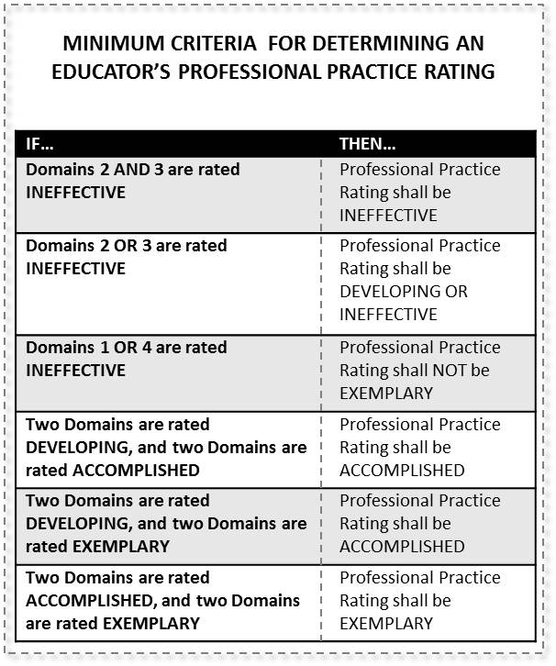

Use Local Student Growth Goal instrument to determine overall Student Growth Rating.

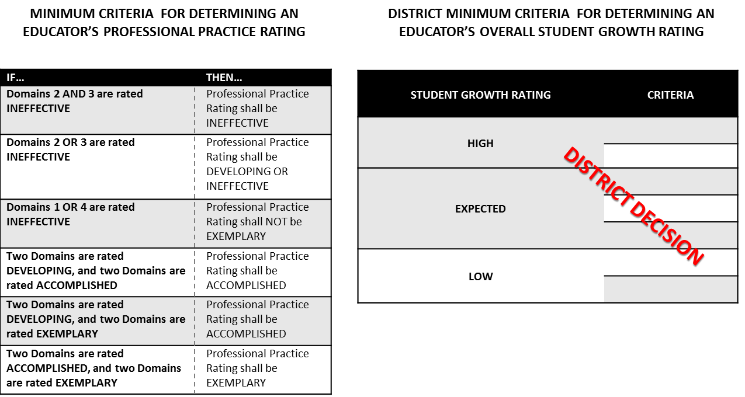

1. Apply State Overall Decision Rules for determining educator’s Overall Performance Category.

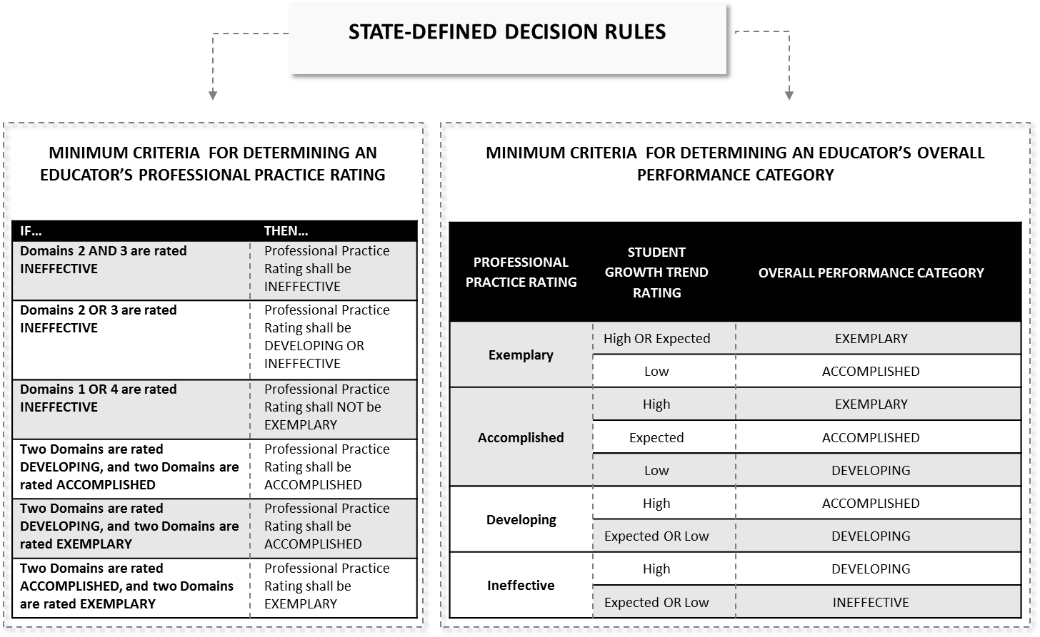

**Required**

* Implement the Overall Performance Category process for determining effectiveness.

**Local District Decision**

* Describe the process for determining low, expected, and high for Overall Student Growth Rating.

**Professional Growth Plan and Summative Cycle**

Based on the overall Professional Practice rating and Student Growth rating, supervisors will help tenured teachers determine the type of Professional Growth Plan and the length of the summative cycle.

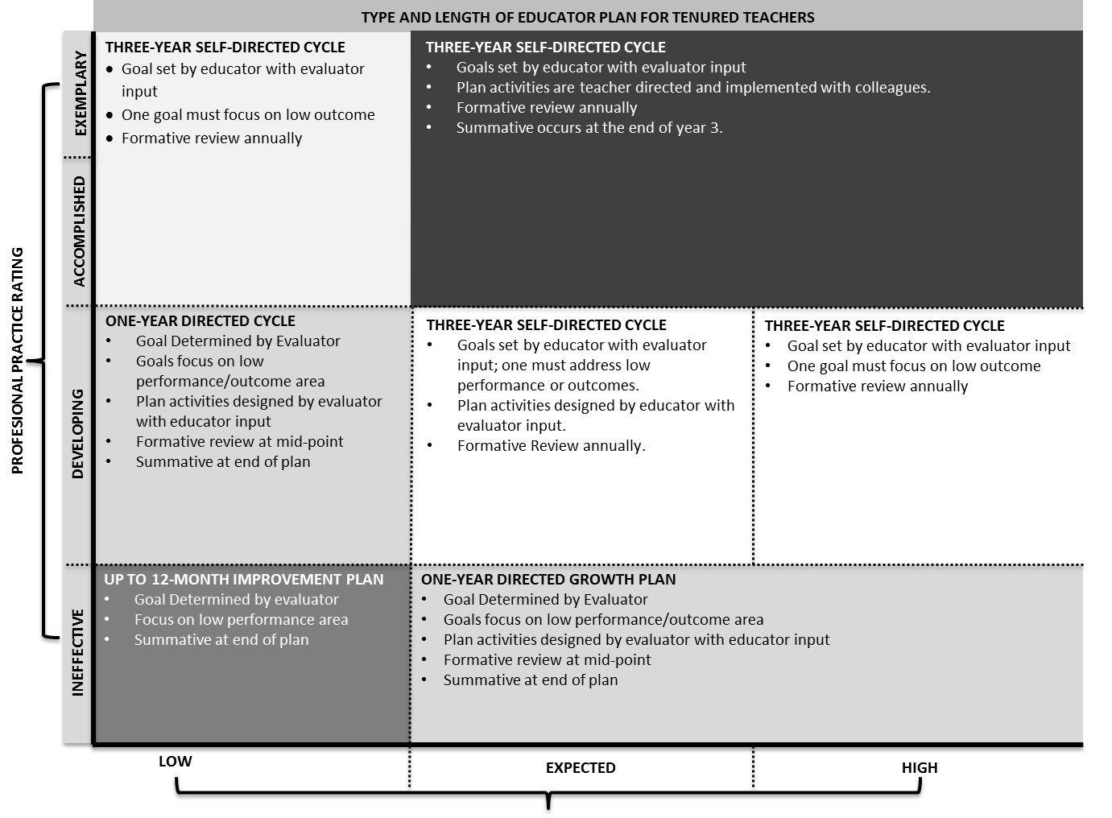

**Appeals**

**Required**

* According to current regulation, districts shall have an appeals process established.

**Professional Growth and Effectiveness System – Principal and Assistant Principal**

The vision for the Professional Growth and Effectiveness System (PGES) is to have every school led by an effective principal.  The goal is to create a fair and equitable system to measure principal effectiveness and act as a catalyst for professional growth.

**Roles and Definitions**

1. **Administrator:** means an administrator who devotes the majority of employed time in the role of principal, for which administrative certification is required by the Education Professional Standards Board pursuant to 16 KAR 3:050
2. **Evaluator:** the immediate supervisor of certified personnel, who has satisfactorily completed all required evaluation training and, if evaluating teachers, observation certification training.
3. **Evaluatee:** District/School personnel that is being evaluated
4. **Professional Growth Plan:** An individualized plan that is focused on improving professional practice and leadership skills and is aligned with educator performance standards and student performance standards, is built using a variety of sources and types of student data that reflect student needs and strengths, educator data, and school/district data, is produced in consultation with the evaluator
5. **Self-Reflection:** means the process by which certified personnel assess the effectiveness and adequacy of their knowledge and performance for the purpose of identifying areas for professional learning and growth
6. **Val-Ed 360°:** An assessment that provides feedback of a principal’s learning-centered behaviors by using input from the principal, his/her supervisor, and teachers. The survey looks at core components (the what) that are listed on the slide, as well as key processes (the how).
7. **TELL Kentucky:** A working conditions survey of all school staff conducted every two years to provide feedback on specific aspects of the school’s work environment.
8. **Other:** *[Please provide any additional required definitions for this section.]*

**Principal Professional Growth and Effectiveness System Components – Overview and Summative Model**

The following graphic outlines the summative model for the Principal Professional Growth and Effectiveness System.

Professional Growth Plans and Self- Reflection

Site-Visits

Val-Ed 360°

Working Conditions Growth Goal

STANDARD 4: Organizational Management

**OVERALL PERFORMANCE CATEGORY**

**PROFESSIONAL PRACTICE**

**STUDENT GROWTH**

**PROFESSIONAL JUDGMENT**

**STANDARD RATINGS**

STANDARD 3: Human Resource Management

STANDARD 2: School Climate

STANDARD 1: Instructional Leadership

**SOURCES OF EVIDENCE TO INFORM PROFESSIONAL PRACTICE**

State Contribution – ASSIST/NGL Goal

**SOURCES OF EVIDENCE TO INFORM STUDENT GROWTH**

Local Contribution – Student Growth Goals (SGGs) based on school need

AND

**PERFORMANCE TOWARD TRAJECTORY**

**STUDENT GROWTH RATINGS**

LOCAL CONTRIBUTION: High, Expected, Low Growth Rating

**PROFESSIONAL JUDGMENT AND DISTRICT-DETERMINED RUBRICS**

STATE CONTRIBUTION: High, Expected, Low Growth Rating

**PROFESSIONAL JUDGMENT & STATE-DETERMINED DECISION RULES** establishing a common understanding of performance thresholds to which all educators are held

STANDARD 6: Professionalism

STANDARD 5: Communication & Community Relations

Evaluators will look for trends and patterns in practice across multiple types of evidence and apply their professional judgment based on this evidence when evaluating a principal. The role of evidence and professional judgment in the determination of ratings on standards and an overall rating is paramount in this process. However, professional judgment is grounded in a common framework: the Principal Performance Standards.

**Principal Performance Standards**

The Principal Performance Standards are designed to support student achievement and professional best-practice through the standards of Instructional Leadership; School Climate; Human Resource Management; Organizational Management; Communication & Community Relations; and Professionalism. Included in the Performance Standards are Performance Indicators that provide examples of observable, tangible behaviors that provide evidence of each standard. The Performance Standards provide the structure for feedback for continuous improvement through individual goals that target professional growth, thus supporting overall student achievement and school improvement. Evidence supporting a principal’s professional practice will be situated within one or more of the 6 standards. Performance will be rated for each standard according to the four performance levels: Ineffective, Developing, Accomplished, and Exemplary. It is important to note that the expected performance level is “Accomplished,” but a good rule of thumb is that it is expected that a principal will “live in Accomplished but occasionally visit Exemplary”. The summative rating will be a holistic representation of performance, combining data from multiple sources of evidence across each standard.

The use of professional judgment based on multiple sources of evidence promotes a more holistic and comprehensive analysis of practice, rather than over-reliance on one individual data point or rote calculation of practice based on predetermined formulas. Evaluators will also take into account how principals respond to or apply additional supports and resources designed to promote student learning, as well as their own professional growth and development. Finally, professional judgment gives evaluators the flexibility to account for a wide variety of factors related to individual principal performance. These factors may include school-specific priorities that may drive practice in one standard, an educator’s number of goals, experience level and/or leadership opportunities, and contextual variables that may impact the learning environment, such as unanticipated outside events or traumas.

Evaluators must use the following categories of evidence in determining overall ratings:

* Required Sources of Evidence (See Appendix D)
  + Professional Growth Planning and Self-Reflection
  + Site-Visits
  + Val-Ed 360°
  + Working Conditions Goal (Based on TELL KY)
  + State and Local Student Growth Goal data

Evaluators may use the following categories of evidence in determining overall ratings:

* Other Measures of Student Learning
* Products of Practice
* Other Sources (e.g. surveys)

**Professional Practice**

The following sections provide a detailed overview of the various sources of evidence used to inform Professional Practice Ratings.

**Professional Growth Planning and Self-Reflection – completed by principals & assistant principals**

The Professional Growth Plan will address realistic, focused, and measurable professional goals. The plan will connect data from multiple sources including site-visit conferences, data on student growth and achievement, and professional growth needs identified through self-assessment and reflection. Self-reflection improves principal practice through ongoing, careful consideration of the impact of leadership practice on student growth and achievement.

**Required:**

* All principals will participate in self-reflection and professional growth planning each year.
* All assistant principals will participate in self-reflection and professional growth planning each year.

**Local District Decision:**

* Explain timeline for submission of PGP for principals/assistant principals.

**Site-Visits – completed by supervisor of principal – formal site visits are not required for assistant principals**

Site visits are a method by which the superintendent may gain insight into the principal’s practice in relation to the standards. During a site visit, the superintendent will discuss various aspects of the job with the principal, and will use the principal’s responses to determine issues to further explore with the faculty and staff. Additionally, the principal may explain the successes and trials the school community has experienced in relation to school improvement.

**Required:**

* Conducted at least twice each year. (Formal site-visits are not required for the assistant principal.)

**Local District Decision:**

* Identify timeline for site-visits.
* Describe conference expectations following site visits.
* Describe site-visit connections to Principal Performance Standards.

**Val-Ed 360° - completed for principals – not completed for assistant principals**

The VAL-ED 360° is an assessment that provides feedback on a principal’s learning-centered behaviors by using input from the principal, his/her supervisor, and teachers. All teachers will participate in the Val-Ed 360°. The results of the survey will be included as a source of data to inform each principal’s professional practice rating.

**Required:**

* Conducted at least once every two years in the school year that TELL Kentucky is not administered.

**Local District Decision:**

* Identify a point of contact for overseeing and administering Val-Ed 360°.
* Identify the frequency of Val-Ed 360° administration.
* Identify the timeline for administration of Val-Ed 360°.
* Describe how Val-Ed 360° results will be used.
* Identify who will have access to Val-Ed 360°

**Working Conditions Goal (Goal inherited by Assistant Principal)**

Principals are responsible for setting a 2-year Working Conditions Growth Goal based on the most recent TELL Kentucky Survey. The principal’s effort to accomplish the Working Conditions Growth Goal is a powerful way to enhance professional performance and, in turn, positively impact school culture and student success.

**Required:**

* Developed following the completion of the TELL Kentucky Survey.
* Minimum of one 2-year goal.

**Local District Decision:**

* Identify the number of Working Conditions Goals that will be required.
* Describe the process used to establish the Working Conditions Goal rubric.
* Describe how a mid-point review will be conducted.
* Identify any additional surveys or evidence that will be used to inform the Working Conditions Goal(s).

**Products of Practice/Other Sources of Evidence**

Additional evidence provided in support of principal practice may include items from the following list (not a comprehensive list):

**Local District Decision:**

* SBDM Minutes
* Faculty Meeting Agendas and Minutes
* Department/Grade Level Agendas and Minutes
* PLC Agendas and Minutes
* Leadership Team Agendas and Minutes
* Instructional Round/Walk-through documentation
* Budgets
* EILA/Professional Learning experience documentation
* Surveys
* Professional Organization memberships
* Parent/Community engagement surveys
* Parent/Community engagement events documentation
* School schedules

**Student Growth**

The following sections provide a detailed overview of the various sources of evidence used to inform Student Growth Ratings. At least one (1) of the Student Growth Goals set by the Principal must address gap populations. Assistant Principals will inherit the SGG (both state and local contributions) of the Principal.

**State Contribution – ASSIST/Next Generation Learners (NGL) Goal Based on Trajectory (Goal inherited by Assistant Principal)**

Principals are responsible for setting at least one student growth goal that is tied directly to the Comprehensive School Improvement Plan located in ASSIST. The superintendent and the principal will meet to discuss the trajectory for the goal and to establish the year’s goal that will help reach the long-term trajectory target. New goals are identified each year based on the ASSIST goals. The goal should be customized for the school year with the intent of helping improve student achievement and reaching the long term goals through on-going improvement.

**Required:**

* Selection based on ASSIST/NGL trajectory.
* Based on Gap population unless Local goal is based on Gap population.

**Local District Decision:**

* Describe process for determining interim trajectory goals.
* Describe process for determining high, expected, low growth.

**Local Contribution – Based on School Need (Goal inherited by Assistant Principal)**

The local goal for Student Growth should be based on school need. It may be developed to parallel the State Contribution or it may be developed with a different focus.

**Required:**

* Based on Gap population unless State goal is based on Gap population.

**Local District Decision:**

* Identify the number of local goals for principal
* Describe process to develop local goals.
* Describe process for determining high, expected, low growth.
  + Describe process for determining high, expected, low growth if multiple local student growth goals are required.

**Determining the Overall Performance Category**

Superintendents are responsible for determining an Overall Performance Category for each principal at the conclusion of their summative evaluation year. The Overall Performance Category is informed by the principal’s ratings on professional practice and student growth.

**Rating Professional Practice**

**Required:**

* Record ratings in CIITS

**Local District Decision:**

* Describe timelines for rating professional practice.

REQUIRED

* Professional Growth Plans and Self-Reflection
* Site-Visit
* Val-Ed 360°/Working Conditions

OPTIONAL

* Other: District-Determined – Must be identified in the CEP

**PROFESSIONAL PRACTICE**

**DOMAIN RATINGS**

STANDARD 1: [I,D,A,E]

**SOURCES OF EVIDENCE TO INFORM PROFESSIONAL PRACTICE**

**PROFESSIONAL JUDGMENT**

STANDARD 2: [I,D,A,E]

STANDARD 3: [I,D,A,E]

STANDARD 4: [I,D,A,E]

STANDARD 6: [I,D,A,E]

STANDARD 5: [I,D,A,E]

**Overall Student Growth Rating**

Overall Student Growth Rating results from a combination of professional judgment and the district-developed instrument. The instrument is designed to aid the evaluator in applying professional judgment to multiple evidences of student growth over time. Student growth ratings must include data from both the local and state contributions.

**Required:**

* Determine the rating using both state and local growth.
* Determine the rating using 3 years of data (when available).
* Record ratings in CIITS.

**Local District Decision:**

* Describe the process used to rate student growth including both state and local contributions.

STATE

* ASSIST/NGL Goal

LOCAL

* Based on school need

**STUDENT GROWTH**

**STUDENT GROWTH RATING**

STUDENT GROWTH [H,E,L]

**SOURCES OF EVIDENCE TO INFORM STUDENT GROWTH**

**PROFESSIONAL JUDGMENT AND DISTRICT-DETERMINED RUBRICS**

**Determining the Overall Performance Category**

A principal’s Overall Performance Category is determined by the evaluator based on the principal’s ratings on each standard, as well as student growth. Evaluators will use the following decision rules for determining the Overall Performance Category:

* **Proposed by the Principal Effectiveness Committee**

|  |  |  |  |  |
| --- | --- | --- | --- | --- |
| **Exemplary** | “Shall” have a minimum of a directed growth plan | | **“Shall” have a minimum of a self-directed growth plan** | **“Shall” have a minimum of a self-directed growth plan** |
| **Accomplished** | **“Shall” have a minimum of a self-directed growth plan** |
| **Developing** | “Shall” have a minimum of a directed growth plan | | | **“Shall” have a minimum of a self-directed growth plan** |
| **Ineffective** | **“Shall”**  **have a minimum of a Corrective Action Plan (Evaluator Directed)** | | | |
|  | **Low**  **Growth** | **Expected Growth** | | **High**  **Growth** |

**Sample Principal PGES Cycle**

The following chart shows the required components for principals and assistant principals over the two year process. **All principals and assistant principals will be evaluated every year.**

**Two Year Cycle of the PPGES**

Administer Formative Val-Ed

Site-Visit by Superintendent

Mid-Year Review with Superintendent

Site-Visit by Superintendent

End-of-Year Review with Superintendent

2013-14

**Administer Summative Val-Ed**

**Review Accountability and ASSIST Goal Results** & Set SGG/PGP/Working Conditions 2-year Goal

Site-Visit by Superintendent

Site-Visit by Superintendent

Mid-Year Review with Superintendent

End-of-Year Review with Superintendent

2014-15

July 2014

**Review Accountability and ASSIST Goal Results** & Set SGG/PGP & Update Working Conditions 2-year Goal

**Administer TELL Kentucky**

**Appendix**

**Appendix A: District Resources**

**Appendix B: Observation**

**Observation Conference Examples**

Examples:

* A district may choose to conduct pre and post conferences for each full observation, but not for mini observations.
* A district may determine that pre-conferences be done through written electronic correspondence, while post-conferences be done in person.
* A district may not require pre-conferencing in any form, but meet in person for a post conference after every observation.

**Observer Certification Support Examples**

Considerations to ensure supervisors have the support needed to be successful in the proficiency system. Examples include

* A scaffolded approach, beginning with initial supports to ensure success during the first administration of the assessment, supports for those who do not pass after one attempt and, supports for those unable to pass the assessment after the second attempt and are subsequently locked out of the system for 90 days.
  + These processes could include collaboration during the initial training (consider a cohort approach to initial certification), additional professional learning opportunities, and mentors.

Considerations the district will use to ensure teachers will have access to certified observers in cases where the supervisor is not certified through the proficiency system and therefore unable to conduct the observation.

* This may include district-level personnel or principals from another building (certified through the proficiency system) conducting the observation with the principal (modeling the process).
  + It is important to note that observation data provided by a substitute observer is considered a valid source of evidence only if the supervisor participated (passively) in the observation.

**Peer Observation Selection Examples**

The following table provides examples for consideration.

|  |  |  |
| --- | --- | --- |
| **Selection/Assignment at the District Level** | **Selection/Assignment at the School Level** | **Selection/Assignment at the Teacher Level** |
| *Examples include:*   * *NBCT Cadre* * *Content Specialists* | *Examples include:*   * *Teacher Leaders* | *Examples include:*   * *Trusted Peers* * *PLC Team Members* |
| * pool selected at the district level, * assigned to teachers/schools at the district level, or * may simply be a pool of Peer Observers from which schools/teachers may choose | * pool selected at the school level, * assigned to teachers at the school level, or * may simply be a pool of Peer Observers from which teachers may choose | * pool self-selected at the school level, * teachers select their own Peer Observer |
| **- Any combination of the above -** | | |

**Appexdix C: Student Growth**

Option A: Rigor Rubics

Two examples are provided below.

|  |  |  |  |
| --- | --- | --- | --- |
| **Structure of the Goal** | **Acceptable** | **Needs Revision** | **Insufficient** |
| *The student growth goal:*  Focuses on a standards-based enduring skill which students are expected to master  Identifies an area of need pertaining to current students’ abilities  Includes growth and proficiency targets that establish and differentiate expected performance for ALL students  Uses appropriate measures for base-line, mid-course, and end of year/course data collection  Explicitly states year-long/course-long interval of instruction | *The student growth goal:*  Focuses on a standards-based enduring skill    Identifies a specific area of need supported by data for current students  Includes a growth target that establishes growth for ALL students; a proficiency target that establishes the mastery expectation for students  Uses measures for collecting baseline, mid-course, and end of year/course data that matches the skill being assessed  Specifies a year-long/course-long interval of instruction | *The student growth goal:*  Focuses on a standards-based skill that does not match enduring skill criteria  Identifies a specific area of need, but lacks supporting data for current students  Includes both a growth target **and** a proficiency target, but fails to differentiate expected performance for one or both targets  Uses measures that fail to clearly demonstrate performance for the identified skill  Specifies less than a year-long/course-long interval of instruction | *The student growth goal:*  Is not standards-based  Is not focused on a specific area of need  Includes only a growth **or** a proficiency target  Uses no baseline data **or** uses irrelevant data  Fails to specify an interval of instruction |
| **Rigor of the Goal** | ***Acceptable*** | ***Needs Revision*** | ***Insufficient*** |
| *The student growth goal:*  Is congruent to KCAS grade level standards and appropriate for the grade level and content area for which it was developed  Identifies measures that demonstrate where students are in meeting or exceeding the intent of the standard(s) being assessed  Includes growth and proficiency targets that are challenging for students, but attainable with support | *The student growth goal:*  Is congruent and appropriate for grade level/content area standards  Identifies measures that allow students to demonstrate their competency in performing at the level intended in the standards being assessed  Includes growth and proficiency targets that are doable, but stretch the outer bounds of what is attainable | *The student growth goal:*  Is congruent to content, but not to grade level standards  Identifies measures that only allow students to demonstrate competency of part, but not all aspects of the standards being assessed  Includes targets that are achievable, but fail to stretch attainability expectations | *The student growth goal:*  Is not congruent or appropriate for grade level/content area standards  Identifies measures that do not assess the level of competency intended in the standards  Includes targets that do not articulate expectations **AND/OR** targets are not achievable |
| **Comparability of Data** | ***Acceptable*** | ***Needs Revision*** | ***Insufficient*** |
| *Data collected for the student growth goal:*  Uses comparable criteria across similar classrooms (classrooms that address the same standards) to determine progress toward mastery of standards/enduring skills | *For similar classrooms, data collected for the student growth goal:*  Reflects use of common measures/rubrics to determine competency in performance at the level intended by the standard(s) being assessed | n/a | *For similar classrooms, data collected for the student growth goal:*  Does not reflect common criteria used to determine progress |



Student Growth Rating

Examples for rating SGG high, expected, or low growth:

* **Pre-Test/Post-Test**

Teachers will use pre- and post-tests to determine the growth identified in their goal. These assessments can be identical or comparable versions.

For example, a music teacher could evaluate a student’s knowledge of scales using a performance task at the beginning of the year and then again at the end of the year. If the teacher asked students to perform the same four scales, this would be an example of identical assessments; if he or she asked the students to perform different scales, this would be a comparable version of the same assessment. Assessment used in this option must meet the district assurance of rigor and comparability as defined in the previous section.

For example, a writing assessment that uses an identical prompt may result in more accurate growth scores, but students may not benefit from repeating the exact same writing assignment. Thus, the prompt for the two writing assessments may be different.

* **Repeated Measures Design**

Teachers will maintain a record of results on short measures that allow students to act on the information obtained from each measure, repeated throughout the length of the SGG. These measures will accompany descriptive feedback rather than evaluative feedback, student involvement in the assessment process, and opportunities for students to communicate their evolving learning while the teaching is in progress. The teacher and principal will then look at the pattern across the repeated administrations to determine the growth rating for the SGG.

For example, early reading teachers may complete weekly running records to track the number of errors that a student makes when reading a text. These repeated measures serve a similar function to a pre- and post-test by illustrating change over time in student learning or performance. Teachers will not utilize repeated measures on which students may demonstrate improvement over time simply due to familiarity with the assessment.

* Holistic Evaluation

Teachers will utilize a holistic evaluation of student growth by combining aspects of a pre- and post-test model with the regularity of a running records/repeated measures approach. Assessment used in this option must meet the district assurance of rigor and comparability as defined in the previous section. Teachers will use a district*-[developed] [adapted] [adopted]* “growth rubric” for a holistic evaluation designed to compare two or more examples of student work.

Holistic rubrics are challenging to construct and implement with fidelity, the district must explain the processes and procedures for ensuring the quality and inter-rater reliability of these rubrics. It may also be a calculation based on quantifying results of all SGG (e.g,. high = 3, expected = 2, low = 1), averaging the results and rating the final score based on previously determined district cut score (which must be defined in the section).

For example, teams of reviewers can rate selected examples together and discuss differences in scores. The goal from these discussions would be to clarify definitions and arrive at a consistent interpretation.

Sources to Consider:

* LDC/MDC
* Program Review
* Performance Tasks
* Problem Based Learning

**Overall Student Growth Rating**

Examples of determining an overall student growth rating

**Decision Rules**

|  |  |
| --- | --- |
| **A teacher has any “Low” ratings** | **CANNOT be rated as HIGH** |
| **Teacher has 50% or more of their ratings as “LOW”** | **SHALL be rated as LOW** |
| **Teacher has more than 50% of their ratings as**  **“DEVELOPING and/or HIGH”** | **CANNOT be rated as “LOW”** |

**Overall Student Growth Rating for District B**

Each rating will be given a numerical weighting.

* + LOW = 1
  + EXPECTED = 2
  + HIGH = 3

The total rankings will be averaged from the previous three years (if available) and applied to the following scale.

|  |  |
| --- | --- |
| **RANKING** | **AVERAGE SCORE** |
| Low | 1.0 – 1.49 |
| Expected | 1.50-2.49 |
| High | 2.50-3 |

**Weighted Overall Growth Rating**

In compiling the ranking of the teachers, our district will weigh the most recent data more heavily than prior years. Please see below to outline the processes for each teacher to follow. Final averages will be applied to the following scale to determine their overall ranking.

**K-PREP teacher with local and state growth goals**

Three years of data will be weighted as follows.

Year 1 Most recent data 50%

Year 2 data 30%

Year 3 data 20%

Each rating will be given a numerical weighting.

* + LOW = 1
  + EXPECTED = 2
  + HIGH = 3

Average the data from each of your years.

If only one piece of data is available for that year you will not need to average, if two pieces of data are available divide by two, three data points divide by three, etc.

To find the weighted average for the local goal you will use the following formula.

**.50(Y1A) + .30(Y2A) + .20(Y3A) = GT**

Y1A=Year 1 Average Y2A=Year 2 Average Y3A=Year 3 Average GT=Growth Total

**Appendix for PPGES**

**SECTION 2: System Components – System Overview and Summative Model**

**Professional Practice**

The following sections provide a detailed overview of the various sources of evidence used to inform Professional Practice Ratings.

**(a) Professional Growth Planning and Self-Reflection (completed annually)**

The Professional Growth Plan will address realistic, focused, and measurable professional goals. The plan will connect data from multiple sources including site-visit conferences, data on student growth and achievement, and professional growth needs identified through self-assessment and reflection. In collaboration with district administrators, principals will identify explicit goals which will drive the focus of professional growth activities, support, and on-going reflection.

Reflective practices and professional growth planning are iterative processes. The principal (1) reflects on his or her current growth needs based on multiple sources of data and identifies an area or areas for focus; (2) collaborates with his or her supervisor to develop a professional growth plan and action steps; (3) implements the plan; (4) regularly reflects on the progress and impact of the plan on his or her professional practice; (5) modifies the plan as appropriate; (6) continues implementation and ongoing reflection; (7) and, finally, conducts a summative reflection on the degree of goal attainment and the implications for next steps.

Self-reflection improves principal practice through ongoing, careful consideration of the impact of leadership practice on student growth and achievement. The Professional Growth Plan is the vehicle through which the outcomes of self-reflection are organized, articulated as specific goals, contextualized in a support framework, and monitored through pre-determined methods. Together, the multiple measures of self-reflection and professional growth planning provide critical information in determining a rating for each standard.

All principals and assistant principals will participate in self-reflection and professional growth planning each year.

**(b) Site-Visits (conducted at least twice a year)**

Site visits are a method by which the superintendent may gain insight into the principals’ practice in relation to the standards. During a site visit, the superintendent will discuss various aspects of the job with the principal, and will use the principal’s responses to determine issues they would like to further explore with the principal’s faculty and staff. Additionally, the principal is provided an opportunity to explain the successes and trials the school community has experienced in relation to school improvement. Site visits are conducted by the superintendent or designee.

**(c) Val-Ed 360° (conducted the year TELL Kentucky is not administered)**

The VAL-ED 360° is an assessment that provides feedback on a principal’s learning-centered behaviors by using input from the principal, his/her supervisor, and teachers. All teachers will participate in the Val-Ed 360°. The results of the survey will be included as a source of data to inform each principal’s professional practice rating.

**(d) Working Conditions Goal**

Connecting TELL Kentucky data to principal performance involves building the capacity for principals and their superintendents to interpret and use TELL Kentucky data to set a target goal for Working Conditions improvement that connects to the Principal Performance Standards and impacts the working conditions within their building. Setting goals—not just any goals, but goals based on whole staff feedback—is a powerful way to enhance professional performance and, in turn, positively impact school culture and student success. Principals are responsible for setting a 2-year Working Conditions Growth Goal that is based on the most recent TELL Kentucky Survey.

**(e) Products of Practice/Other Sources of Evidence**

Principals may provide additional evidences to support assessment of their own professional practice. These evidences should yield information related to the principal’s practice within the standards. These evidences should be part of the regular practice of the principal and not created solely for use as evidence. In other words, evidence must be naturally occurring products related to the day-to-day work of principal leadership and learning.

**Student Growth**

The following sections provide a detailed overview of the various sources of evidence used to inform Student Growth Ratings. At least one (1) of the Student Growth Goals set by the Principal must address gap populations. Assistant Principals will inherit the SGGs (both state and local contributions) of the Principal.

**(a) State Contribution – ASSIST/NGL Goal Based on Trajectory**

Principals are responsible for setting at least one student growth goal that is tied directly to the Comprehensive School Improvement Plan that is in ASSIST. The superintendent and the principal will meet to discuss the trajectory for the goal and to establish the year’s goal that will help reach the long-term trajectory target. New goals are identified each year based on the ASSIST goals. The goal should be customized for the school year with the intent of helping improve student achievement and reaching the long term goals through on-going improvement.

**(b) Local Contribution – Based on School Need**

The local goal for Student Growth should be based on school need. It may be developed to parallel the State Contribution or it may be developed with a different focus.

Following are the assurances that all SGGs meet the specified criteria for rigor.

The district will develop a plan for helping principals select appropriate SGGs (both state and local contributions). Please identify what criteria the district has set in helping principals select goals. These criteria may be as straightforward as selecting the goal that has the greatest gap from the current results to the trajectory results. It may be more involved by including a review of current results and a review of student growth goals set by teachers for the current school year to ensure connectivity between teacher and principal efforts. Once selection is complete, principals will develop a goal that is rigorous and realistic for the current school year. The goal should be:

* based on actions that can be taken by the principal to impact results as opposed to actions that can be assigned by the principal to teachers
* connected to other school/district initiatives where appropriate

Once the goal has been set and a plan for accomplishing the goal completed, districts must develop a rubric to determine the level of success in achieving the goal and determining the rating for the principal’s student growth component. The rating will be based on high/expected/low.Please identify the criteria that will be used to determine a rating based on the results. Districts may decide that this will be a set range around the expected growth allowing for the uncertainty of what results will be. As an example, the district may determine that 2 points above or below the goal equates to “expected” growth. Anything higher may be classified as “high” and anything lower classified as “low.” If requiring more than one local SGG, please explain how they will arrive at a single local Student Growth result. This may include a matrix or index or other process as determined by the district.

**SECTION 3: Determining the Overall Performance Category**

Superintendents are responsible for determining an Overall Performance Category for each principal at the conclusion of their summative evaluation year. The Overall Performance Category is informed by the educator’s ratings on professional practice and student growth. The evaluator determines the Overall Performance Category based on professional judgment informed by evidence that demonstrates the educator's performance against the Standards, district-developed rubrics, and decision rules that establish a common understanding of performance thresholds to which all educators are held. What follows is a description of each component used to inform the Overall Performance Category.

**(a) Rating Professional Practice**

The Kentucky Principal Performance Standards stand as the critical rubric for providing principals and evaluators with concrete descriptions of practice associated with specific standards. Each standard describes a behavior or related set of behaviors that principals and evaluators can prioritize for evidence-gathering, feedback, and eventually, evaluation. Evaluators will organize and analyze evidence for each individual principal based on these concrete descriptions of practice.

Evaluators and principals will be engaged in ongoing dialogue throughout the evaluation cycle. The process concludes with the evaluator’s analysis of evidence and the final assessment of practice in relation to performance described under each Standard at the culmination of an educator’s cycle.

STANDARD 6: [I,D,A,E]

STANDARD 5: [I,D,A,E]

REQUIRED

* Professional Growth Plans and Self-Reflection
* Site-Visit
* Val-Ed 360°/Working Conditions

OPTIONAL

* Other: District-Determined – Must be identified in the CEP

**PROFESSIONAL PRACTICE**

**DOMAIN RATINGS**

STANDARD 1: [I,D,A,E]

**SOURCES OF EVIDENCE TO INFORM PROFESSIONAL PRACTICE**

**PROFESSIONAL JUDGMENT**

STANDARD 2: [I,D,A,E]

STANDARD 3: [I,D,A,E]

STANDARD 4: [I,D,A,E]

**(b) Rating Student Growth**

Student Growth Ratings result from a combination of professional judgment and the district-developed [rubric] [decision rules] for summative student growth ratings. The [rubric is] [decision rules are] designed to aid the evaluator in applying professional judgment to multiple evidences of student growth over time. Student growth ratings must include data from both the local and state contributions. Please describe the process and/or instrument to be used and include it as an attachment to this document. This may be a rubric or decision rules, much like the holistic evaluation instrument identified the student growth section. It may also be a calculation based on quantifying results of all SGG and School Report Card/Accountability data (e.g., high = 3, expected = 2, low = 1), averaging the results and rating the final score based on previously determined district cut score (which must be defined in the section). If choosing to use a rubric or decision rules, please describe the processes and procedures for ensuring quality and inter-rater reliability (see holistic evaluation section above).

STATE

* ASSIST/NGL Goal

LOCAL

* Based on school need

**STUDENT GROWTH**

**STUDENT GROWTH RATING**

STUDENT GROWTH [H,E,L]

**SOURCES OF EVIDENCE TO INFORM STUDENT GROWTH**

**PROFESSIONAL JUDGMENT AND DISTRICT-DETERMINED RUBRICS**