Graphs of Quadratics Station

At this station, you will find two number cubes. Each person will roll the cube with the + and – signs three times. Place the sign from the first roll in the first oval below, the sign from the second roll in the second oval, and the sign from the third roll in the third oval. Then roll the cube with the numbers three times, placing one number in each of the squares in the equation. Use your equation to answer the following questions.

y = x² x

1) What are the values of a, b, and c in your quadratic equation?
a = ________
b = ________
c = ________

2) Complete the table of values for your quadratic equation. Then graph the parabola on the graph provided.
x | y
-3
-2
-1
0
1
2
3

3) What is the vertex of your parabola?

4) What are the coordinates of the parabola’s y-intercept?

5) Draw in the axis of symmetry with a colored pencil. What is the equation of the axis of symmetry?

6) How would the graph of your parabola change if the first oval had the opposite sign?

7) Do you think that the graph of $y= \frac{1}{2}{(x-2)}^{2}$ will be wider or narrower than your graph? Why? Graph this parabola on the same grid as yours in a different color.

8) What would be the equation of your parabola if the y-intercept were 5 units higher than it is now?

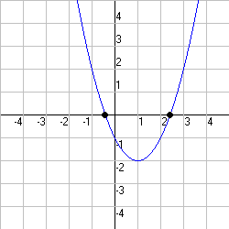
8) Look at the graph at the right. Determine the equation for the graph shown. Show all work.

