http://www.math-drills.com/algebra/algebra_expressions_simplifying_mdas_2v_5t_001.html

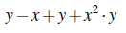 | 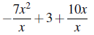 | 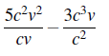 | END
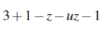 | 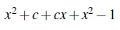 | 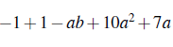 | 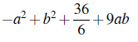
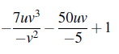 | 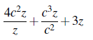 | 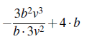 | 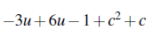

Match this box
print 2-sided short edge
Match this box
print 2-sided short edge

START | Simplifying Algebraic Expressions Turnover Cards | 17uv+1 | Simplifying Algebraic Expressions Turnover Cards | 4c²+cz+3z | Simplifying Algebraic Expressions Turnover Cards | -bv+4b | Simplifying Algebraic Expressions Turnover Cards
c²+3u+c-1 | Simplifying Algebraic Expressions Turnover Cards | -uz-z+3 | Simplifying Algebraic Expressions Turnover Cards | 2x²+cx+c-1 | Simplifying Algebraic Expressions Turnover Cards | -ab+10a²+7a | Simplifying Algebraic Expressions Turnover Cards
-a2+b²+9ab+6 | Simplifying Algebraic Expressions Turnover Cards | x²y+2y-x | Simplifying Algebraic Expressions Turnover Cards | -7x+13 | Simplifying Algebraic Expressions Turnover Cards | 2cv | Simplifying Algebraic Expressions Turnover Cards

